**Signing Up Into GitHub**

1. Navigate to <https://github.com/>.
2. Sign Up
3. Fill in the following Widget

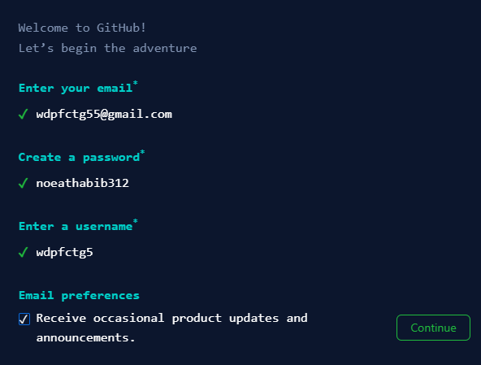

1. Click Continue
2. Nest Window:

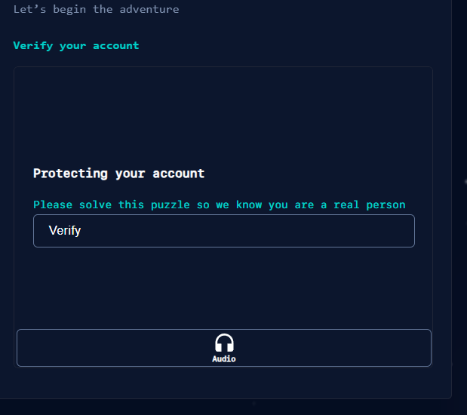

1. Click Verify
2. Next Widget

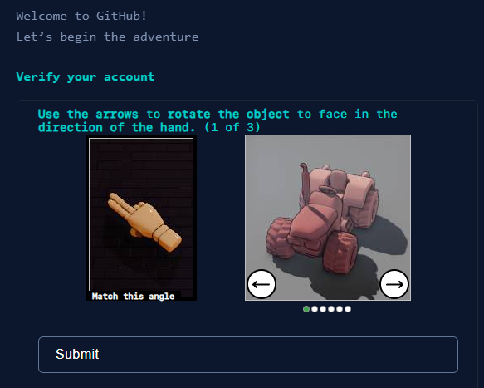

1. Follow the instructions and click Submit
2. A email will be sent to your gmail. Copy the Code and paste it in next Widget
3. Next Widget:

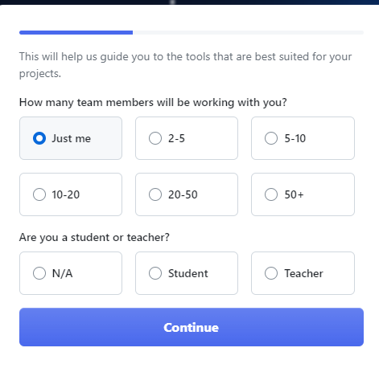

1. Click Continue>Next Widget

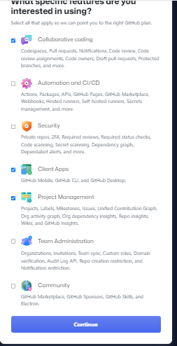

1. Click Continue>Next Step

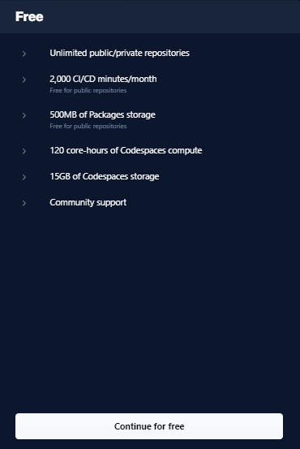

1. Continue for free
2. Dashboard

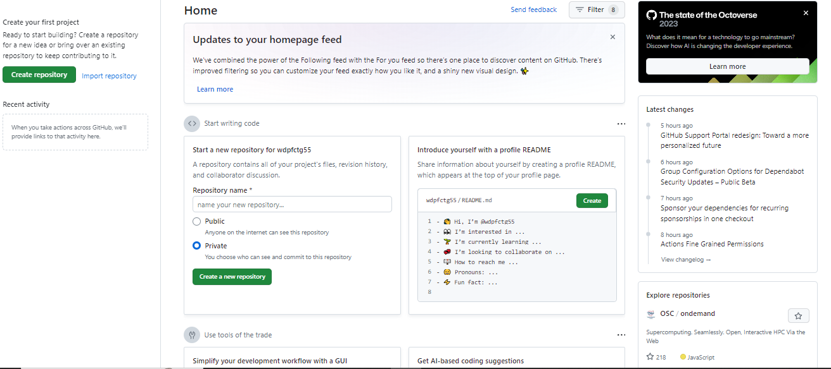

**File Repository in GitHub**

* 1. We shall create a github project on Repository Name: Starting Github>Public>Create a new Repository. Widget

